**The Answers:**

Before answering the question, I would like to mention that I really enjoyed this data exercise, it is a really good analytical project and I would like to add this project in my Portfolio.

Using the three datasets given:

1. **Provide a quantitative assessment of whether the marketing campaign was successful. How and why did you choose your specific success metric(s)?**

Below are three quantitative Assessments which proves that marketing campaign was successful: -

1. **Increase in Deposit Amounts.**

|  |  |  |  |  |  |
| --- | --- | --- | --- | --- | --- |
| **% Increase in Actual Deposit** |  |  |  |  |  |
| **DEPOSIT_TYPE** | **MONTH_NAME** | **SUM(DEPOSIT_AMOUNT)** | **% Increased from First Month** | **Increment Sales** | **Month** |
| Actual Deposit | Month 1 | 14,278,252 | NA | NA | Pre-campaign |
| Actual Deposit | Month 2 | 14,651,163 | Baseline | Baseline |
| **Actual Deposit** | **Month 3** | **19,522,405** | **37** | **4,871,242** | **Campaign** |
| Actual Deposit | Month 4 | 18,339,366 | 28 | 3,688,203 | Post-Campaign |
| Actual Deposit | Month 5 | 18,036,260 | 26 | 3,385,097 |
|  |  | **Total** | 91 | 11,944,542 |  |
|  |  | **Average** | **30.33333333** |  |  |
|  |  | ***ROI*** | ***138.89084*** |  |  |

1. **Increase in number of transactions.**

|  |  |  |
| --- | --- | --- |
| **Transactions Details** |  |  |
| **DEPOSIT_TYPE** | **MONTH_NAME** | **No. of Transactions** |
| Actual Deposit | Month 1 | 37,447 |
| Actual Deposit | Month 2 | 38,770 |
| **Actual Deposit** | **Month 3** | **52,215** |
| Actual Deposit | Month 4 | 50,799 |
| Actual Deposit | Month 5 | 49,779 |
|  |  |  |
| 1. **Increase in New Customers.** |  |  |
| **Customer Details** |  |  |
| **DEPOSIT_TYPE** | **MONTH_NAME** | **No. of Customers** |
| Actual Deposit | Month 1 | 29,022 |
| Actual Deposit | Month 2 | 29,760 |
| **Actual Deposit** | **Month 3** | **40,027** |
| Actual Deposit | Month 4 | 37,374 |
| Actual Deposit | Month 5 | 37,403 |

***How and why did you choose your specific success metric(s)?

The **Incremental Sales** measures the contribution of your marketing efforts to increasing sales revenue. This KPI emphasizes the close relationship between sales and marketing, and how that relationship benefits your organization. Marketing attracts qualified leads, and sales converts those leads into paying customers.

For the given data the number of settlement agreements Freedom can negotiate is proportional to the monthly deposited amount which is propositional to incremental sales.

1. **Based on the provided data, how would you recommend campaign strategy be adjusted in the future to improve performance?**

Ans. Please refer below points:-

1. Age Factor and Client Residential Status:- Age Group between 40-60 and who own a residence have more probability to sign up in the program.

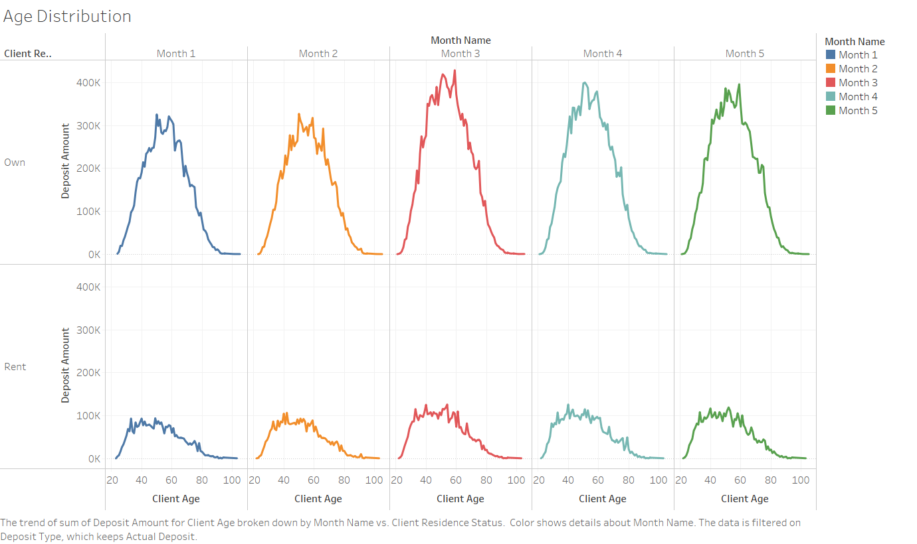

1. Need to plan campaign so we can get some more traffic from other geographical region like we have in west.

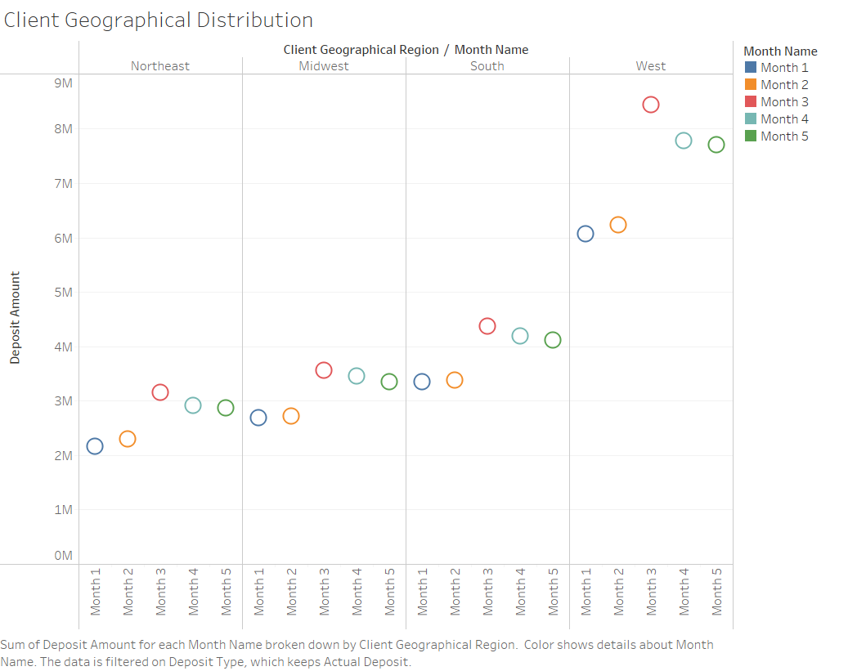

1. **How to do you think campaign performance would have changed if we did not run the campaign in Month 3, but instead postponed it until month 6? Provide an incremental number versus your result in Question #1.**

Based on the data, sum of deposit increase from baseline in around 3% so if we don’t run the campaign then we might run into same situation and started seeing some improvements starting from campaign month.

|  |  |  |  |  |
| --- | --- | --- | --- | --- |
| **% Increase in Actual Deposit** |  |  |  |  |
| **DEPOSIT_TYPE** | **MONTH_NAME** | **SUM(DEPOSIT_AMOUNT)** | **% Increased from First Month** | **Month** |
| Actual Deposit | Month 1 | 14,278,252 | Baseline | Pre-campaign |
| Actual Deposit | Month 2 | 14,651,163 | 3 |
| Actual Deposit | Month 3 | 15,090,698 | 3 |
| Actual Deposit | Month 4 | 15,543,419 | 3 |
| Actual Deposit | Month 5 | 16,009,721 | 3 |
| **Actual Deposit** | **Month 6** | **19,522,405** | 22 | **Campaign** |
| Actual Deposit | Month 7 | 18,339,366 | -6 | Post-Campaign |
| Actual Deposit | Month 8 | 18,036,260 | -2 |

1. **Is there anything not in the provided dataset that you think would provide value if added? If so, how would you strategize gathering and leveraging the additional information?**

In order to perform detail analysis, we need more durations of the data and few more data points.

* 12 Months of Data to analyze to get better picture.
* Target variable from past campaign so we can build prediction model for future campaign
* Channel Mix Information

To gather this information need to closely work with sales and data engineering team so they will start capturing these additional data points.